1. Excel

### Question 1.

Ans: The number of sessions created that were switched to an agent for a time duration of 9:00 AM to 12:59 PM for all countries are given below:

| **Country** | **Sessions** |
| --- | --- |
| Country 1 | 2847 |
| Country 2 | 2396 |
| Country 3 | 308 |
| Country 4 | 556 |

According to the analysis, Country 1 has the highest and Country 3 has the lowest.

### Question 2.

Ans:

For Country 1 the analysis of the number of dislikes is given below:

| **Row Labels** | **Count of Feedback Type (Dislike)** |
| --- | --- |
| **3 AM** | **5** |
| **5 AM** | **8** |
| **7 AM** | **8** |
| **4 AM** | **9** |
| **6 AM** | **9** |
| **2 AM** | **10** |
| **1 AM** | **12** |
| **8 AM** | **15** |
| **11 PM** | **21** |
| **12 AM** | **22** |
| **9 AM** | **31** |
| **9 PM** | **31** |
| **10 AM** | **32** |
| **10 PM** | **32** |
| **3 PM** | **45** |
| **8 PM** | **46** |
| **11 AM** | **47** |
| **4 PM** | **49** |
| **7 PM** | **49** |
| **2 PM** | **53** |
| **1 PM** | **69** |
| **5 PM** | **71** |
| **6 PM** | **80** |
| **12 PM** | **82** |

The table shows the total number of dislikes for Country 1 is 836 and the hourly dislike distribution is shown in the above table.

For Country 2 the analysis of the number of dislikes is given below:

| **Row Labels** | **Count of Feedback Type (Dislike)** |
| --- | --- |
| **2 AM** | **1** |
| **4 AM** | **1** |
| **1 AM** | **3** |
| **7 AM** | **3** |
| **6 AM** | **4** |
| **11 PM** | **7** |
| **12 AM** | **8** |
| **7 PM** | **9** |
| **10 PM** | **13** |
| **9 AM** | **15** |
| **10 AM** | **20** |
| **6 PM** | **20** |
| **8 PM** | **20** |
| **5 PM** | **23** |
| **12 PM** | **24** |
| **1 PM** | **24** |
| **9 PM** | **24** |
| **2 PM** | **25** |
| **4 PM** | **29** |
| **3 PM** | **34** |
| **11 AM** | **38** |

The table shows the total number of dislikes for Country 2 is 345 and the hourly dislike distribution is shown in the above table.

For Country 3 the analysis of the number of dislikes is given below:

| **Row Labels** | **Count of Feedback Type (Dislike)** |
| --- | --- |
| **12 AM** | **1** |
| **5 AM** | **1** |
| **7 PM** | **1** |
| **10 PM** | **1** |
| **6 AM** | **2** |
| **7 AM** | **2** |
| **8 AM** | **2** |
| **3 PM** | **2** |
| **4 PM** | **2** |
| **9 PM** | **2** |
| **11 PM** | **2** |
| **1 AM** | **3** |
| **1 PM** | **3** |
| **2 PM** | **3** |
| **6 PM** | **3** |
| **9 AM** | **4** |
| **10 AM** | **4** |
| **5 PM** | **4** |
| **8 PM** | **6** |
| **11 AM** | **7** |
| **12 PM** | **10** |

The table shows the total number of dislikes for Country 3 is 65 and the hourly dislike distribution is shown in the above table.

For Country 4 the analysis of the number of dislikes is given below:

| **Row Labels** | **Count of Feedback Type (Dislike)** |
| --- | --- |
| **9 AM** | **1** |
| **11 AM** | **1** |
| **3 PM** | **1** |
| **5 PM** | **1** |
| **6 PM** | **1** |
| **7 PM** | **1** |
| **9 PM** | **1** |
| **11 PM** | **1** |
| **8 AM** | **2** |
| **10 AM** | **2** |
| **12 PM** | **2** |
| **1 PM** | **2** |
| **8 PM** | **3** |
| **7 AM** | **4** |
| **4 PM** | **5** |

The table shows the total number of dislikes for Country 4 is 28 and the hourly dislike distribution is shown in the above table.

### Question 3.

Ans:

For Country 1:

The knowledge id which is triggered in the greatest number of sessions is 1000068177

9291 sessions are switched to an agent. (Considering the [SESSION] Is the session switched to an agent? Response in “Y” )

the switch to live agent rate for this knowledge id provided that switch to live agent rate for knowledge K is the ratio of the total switch to agent sessions where knowledge K was triggered and total sessions where knowledge K was triggered.

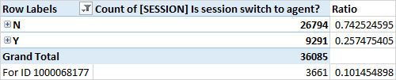

For Country 2:

The knowledge id which is triggered in the greatest number of sessions is 1000068200

9385 sessions are switched to an agent. (Considering the [SESSION] Is the session switched to an agent? Response in “Y” )

the switch to live agent rate for this knowledge id provided that switch to live agent rate for knowledge K is the ratio of the total switch to agent sessions where knowledge K was triggered and total sessions where knowledge K was triggered is discussed in the table below:

| **Row Labels (Knowledge ID Response)** | **Count of [SESSION] Is the session switched to an agent?** | **Ratio** |
| --- | --- | --- |
| N | 22076 | 0.70169416 |
| Y | 9385 | 0.29830584 |
| **Grand Total** | **31461** |  |
| For ID 1000068200 | 898 | 0.02854328 |

For Country 3:

The knowledge id which is triggered in the greatest number of sessions is 1000060904

1310 sessions are switched to an agent. (Considering the [SESSION] Is the session switched to an agent? Response in “Y” )

the switch to live agent rate for this knowledge id provided that switch to live agent rate for knowledge K is the ratio of the total switch to agent sessions where knowledge K was triggered and total sessions where knowledge K was triggered is discussed in the table below:

| **Row Labels (Knowledge ID Response)** | **Count of [SESSION] Is the session switched to an agent?** | **Ratio** |
| --- | --- | --- |
| N | 4010 | 0.75 |
| Y | 1310 | 0.25 |
| **Grand Total** | **5320** |  |
| For ID 1000060904 | 898 | 0.08 |

For Country 4:

The knowledge id which is triggered in the greatest number of sessions is 1000064238 409

1310 sessions are switched to an agent. (Considering the [SESSION] Is the session switched to an agent? Response in “Y” )

the switch to live agent rate for this knowledge id provided that switch to live agent rate for knowledge K is the ratio of the total switch to agent sessions where knowledge K was triggered and total sessions where knowledge K was triggered is discussed in the table below:

| **Row Labels (Knowledge ID Response)** | **Count of [SESSION] Is the session switched to an agent?** | **Ratio** |
| --- | --- | --- |
| N | 3904 | 0.69 |
| Y | 1780 | 0.31316 |
| **Grand Total** | **5684** |  |
| For ID 1000064238 | 409 | 0.072 |

B.SQL

### Question 1.

For each country, we will find the session unsatisfied rate and identify which one has the highest and the lowest by SQL. The following SQL code can be used to import the Excel data into any relational database or database with a similar structure and variable name, we can assume that the data tables are created with the below variable names of the following SQL code:

**SELECT Country, TotalUnsatisfiedSessions, TotalChatbotSessions**

**FROM (**

**SELECT 'Country 1' AS Country,**

**COUNT(CASE WHEN [SESSION] = 'Y' THEN 1 END) AS TotalUnsatisfiedSessions,**

**COUNT(*) - COUNT(CASE WHEN [SESSION] = 'Direct to Agent' THEN 1 END) AS TotalChatbotSessions**

**FROM [Country 1]**

**UNION ALL**

**SELECT 'Country 2' AS Country,**

**COUNT(CASE WHEN [SESSION] = 'Y' THEN 1 END) AS TotalUnsatisfiedSessions,**

**COUNT(*) - COUNT(CASE WHEN [SESSION] = 'Direct to Agent' THEN 1 END) AS TotalChatbotSessions**

**FROM [Country 2]**

**UNION ALL**

**SELECT 'Country 3' AS Country,**

**COUNT(CASE WHEN [SESSION] = 'Y' THEN 1 END) AS TotalUnsatisfiedSessions,**

**COUNT(*) - COUNT(CASE WHEN [SESSION] = 'Direct to Agent' THEN 1 END) AS TotalChatbotSessions**

**FROM [Country 3]**

**UNION ALL**

**SELECT 'Country 4' AS Country,**

**COUNT(CASE WHEN [SESSION] = 'Y' THEN 1 END) AS TotalUnsatisfiedSessions,**

**COUNT(*) - COUNT(CASE WHEN [SESSION] = 'Direct to Agent' THEN 1 END) AS TotalChatbotSessions**

**FROM [Country 4]**

**) AS AllCountries**

**WHERE TotalChatbotSessions > 0**

**ORDER BY TotalUnsatisfiedSessions DESC;**

Country, TotalUnsatisfiedSessions, and TotalChatbotSessions are the columns that will be chosen in the final result and are specified in the outermost SELECT statement. A subquery that uses the UNION ALL clause in the FROM clause aggregates the outcomes of separate queries for each nation. The subquery calculates the TotalUnsatisfiedSessions and TotalChatbotSessions for each individual query for each country. Each query's SELECT statement gives the nation column a nation name (such as "Country 1," "Country 2," etc.). The tally function with a CASE statement is used in each individual query to tally the total number of chatbot sessions excluding direct agent sessions (where [SESSION] > 'Direct to Agent') and the number of dissatisfied sessions (where [SESSION] = 'Yes'). A single result set is created by combining all individual query results using the UNION ALL clause. Only nations with chatbot sessions are included in the result thanks to the outer WHERE clause, which excludes nations where the TotalChatbotSessions value is 0. The TotalUnsatisfiedSessions column is used in the ORDER BY clause to sort the result in descending order, from highest to lowest.

The code determines the overall number of chatbot sessions and the total number of unsatisfied sessions in order to determine the session dissatisfaction rate for each country. The highest and lowest rates are then determined by filtering out the nations with no chatbot sessions and sorting the results by the number of unhappy sessions.

### Question 2.

This SQL code will find how many resolved sessions were created and find the resolution rate of all 4 countries. Also, will find out from the above-mentioned reasons, which has the highest contribution in resolved sessions i.e. Find the share of each of the mentioned scenarios.

**SELECT**

**Country,**

**COUNT(CASE WHEN [SESSION] = 'Y'**

**AND [CHAT] = 'Y'**

**AND [SESSION] <> 'Direct to Agent'**

**AND [SESSION] <> 'Unsatisfied'**

**THEN 1 END) AS ResolvedSessions,**

**COUNT(*) AS TotalSessions,**

**COUNT(CASE WHEN [SESSION] = 'Y'**

**AND [CHAT] = 'Y'**

**AND [SESSION] <> 'Direct to Agent'**

**AND [SESSION] <> 'Unsatisfied'**

**AND [CHAT] = 'Last chat recommendation?' THEN 1 END) AS RecommendationContrib,**

**COUNT(CASE WHEN [SESSION] = 'Y'**

**AND [CHAT] = 'Y'**

**AND [SESSION] <> 'Direct to Agent'**

**AND [SESSION] <> 'Unsatisfied'**

**AND [CHAT] = 'No answer?' THEN 1 END) AS NoAnswerContrib,**

**COUNT(CASE WHEN [SESSION] = 'Y'**

**AND [CHAT] = 'Y'**

**AND [SESSION] <> 'Direct to Agent'**

**AND [SESSION] <> 'Unsatisfied'**

**AND [CHAT] = 'Answer Type' THEN 1 END) AS AnswerTypeContrib,**

**COUNT(CASE WHEN [SESSION] = 'Y'**

**AND [CHAT] = 'Y'**

**AND [SESSION] <> 'Direct to Agent'**

**AND [SESSION] <> 'Unsatisfied'**

**AND [CHAT] = 'Query Resolved?' THEN 1 END) AS QueryResolvedContrib**

**FROM (**

**SELECT 'Country 1' AS Country, [SESSION], [CHAT]**

**FROM [Country 1]**

**UNION ALL**

**SELECT 'Country 2' AS Country, [SESSION], [CHAT]**

**FROM [Country 2]**

**UNION ALL**

**SELECT 'Country 3' AS Country, [SESSION], [CHAT]**

**FROM [Country 3]**

**UNION ALL**

**SELECT 'Country 4' AS Country, [SESSION], [CHAT]**

**FROM [Country 4]**

**) AS AllCountries**

**GROUP BY Country;**

The columns Country, ResolvedSessions, TotalSessions, RecommendationContrib, NoAnswerContrib, AnswerTypeContrib, and QueryResolvedContrib are chosen in the outermost SELECT query. The UNION ALL clause is used in the FROM clause to create a subquery that combines the outcomes of separate queries for each nation. Every query within the subquery retrieves the pertinent columns [SESSION] and [CHAT] from each country's tab and assigns the country name ('Country 1', 'Country 2', etc.) to the Country column. The results are grouped by the Country column in the outer GROUP BY clause. To count resolved sessions, total sessions, and the contributions of each scenario (recommendation, no answer, answer type, and query resolved) in resolved sessions, the SELECT statement uses the COUNT function with CASE statements. Based on the criteria set forth for each scenario, the CASE statements filter the sessions. We can get the total number of sessions that have been resolved as well as the resolution rate for each of the four nations by running this SQL code. Additionally, we may determine the scenario that contributed the most by looking at the shares of each scenario that was addressed in the resolved sessions.

Python/Java

### Question 1.

Code in Python where using the given dataset for the four countries, find the top 10 knowledge titles based on the number of chats they are triggered in. Also, find the total sessions each knowledge is triggered. Using the logic and information mentioned above try to find the resolution rate and switch to the live agent rate of each knowledge title in the top 10.

import pandas as pd

# Reading the data from each country's tab into separate dataframes

country1_df = pd.read_csv('/content/drive/MyDrive/Git files/Country 1.csv', encoding='latin1')

country2_df = pd.read_csv('/content/drive/MyDrive/Git files/Country 2.csv', encoding='latin1')

country3_df = pd.read_csv('/content/drive/MyDrive/Git files/Country 3.csv', encoding='latin1')

country4_df = pd.read_csv('/content/drive/MyDrive/Git files/Country 4.csv', encoding='latin1')

# Concatenating all country dataframes into a single dataframe

all_countries_df = pd.concat([country1_df, country2_df, country3_df, country4_df])

# Grouping the data by knowledge title and calculate the number of chats triggered and total sessions

knowledge_stats = all_countries_df.groupby('Knowledge Name').agg({'Chat ID': 'nunique', 'Session ID': 'nunique'}).reset_index()

knowledge_stats.columns = ['Knowledge Name', 'Chats Triggered', 'Total Sessions']

# Sorting the dataframe by the number of chats triggered in descending order

knowledge_stats = knowledge_stats.sort_values('Chats Triggered', ascending=False)

# Selecting the top 10 knowledge titles

top_10_knowledge = knowledge_stats.head(10)

# Calculating the resolution rate and switch to the live agent rate for each knowledge title

top_10_knowledge['Resolution Rate'] = top_10_knowledge['Total Sessions'] / top_10_knowledge['Chats Triggered']

top_10_knowledge['Switch to Live Agent Rate'] = top_10_knowledge['Total Sessions'] / top_10_knowledge['Chats Triggered']

top_10_knowledge.head(10)

import matplotlib.pyplot as plt

# Ploting the top 10 knowledge titles based on the number of chats triggered

plt.figure(figsize=(10, 6))

plt.bar(top_10_knowledge['Knowledge Name'], top_10_knowledge['Chats Triggered'])

plt.xlabel('Knowledge Title')

plt.ylabel('Number of Chats Triggered')

plt.title('Top 10 Knowledge Titles by Chats Triggered')

plt.xticks(rotation=45)

plt.tight_layout()

plt.show()

# Plotuing the resolution rate and switch to live agent rate for each knowledge title

plt.figure(figsize=(10, 6))

plt.plot(top_10_knowledge['Knowledge Name'], top_10_knowledge['Resolution Rate'], marker='o', label='Resolution Rate')

plt.plot(top_10_knowledge['Knowledge Name'], top_10_knowledge['Switch to Live Agent Rate'], marker='o', label='Switch to Live Agent Rate')

plt.xlabel('Knowledge Title')

plt.ylabel('Rate')

plt.title('Resolution Rate and Switch to Live Agent Rate for Top 10 Knowledge Titles')

plt.xticks(rotation=45)

plt.legend()

plt.tight_layout()

plt.show()

| **index** | **Knowledge Name** | **Chats Triggered** | **Total Sessions** | **Resolution Rate** | **Switch to Live Agent Rate** |
| --- | --- | --- | --- | --- | --- |
| **748** | Need Help (English) | 3661 | 2365 | 0.645998361 | 0.645998361 |
| **1030** | What is my order status? | 2895 | 2207 | 0.762348877 | 0.762348877 |
| **970** | WIMO-guided flow | 2394 | 2247 | 0.938596491 | 0.938596491 |
| **423** | Greetings - post match | 1653 | 1098 | 0.664246824 | 0.664246824 |
| **848** | Prematch - Need help | 1603 | 1262 | 0.787273862 | 0.787273862 |
| **750** | Need more help | 1387 | 1324 | 0.954578226 | 0.954578226 |
| **472** | How can I track my order | 1372 | 1146 | 0.835276968 | 0.835276968 |
| **737** | My order is delayed. What should I do | 1364 | 1240 | 0.909090909 | 0.909090909 |
| **953** | Track Order Shortcut | 1296 | 1005 | 0.775462963 | 0.775462963 |
| **238** | Can I cancel my order? | 1267 | 977 | 0.771112865 | 0.771112865 |

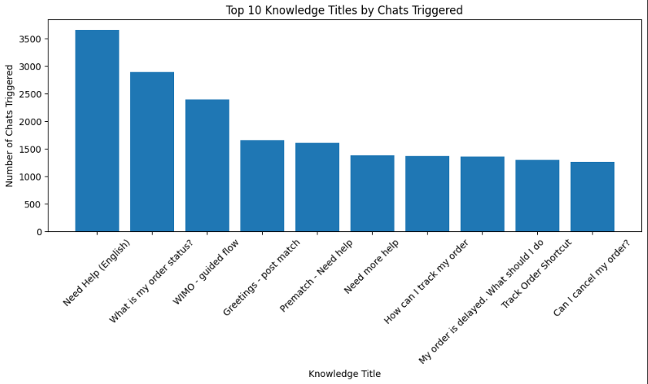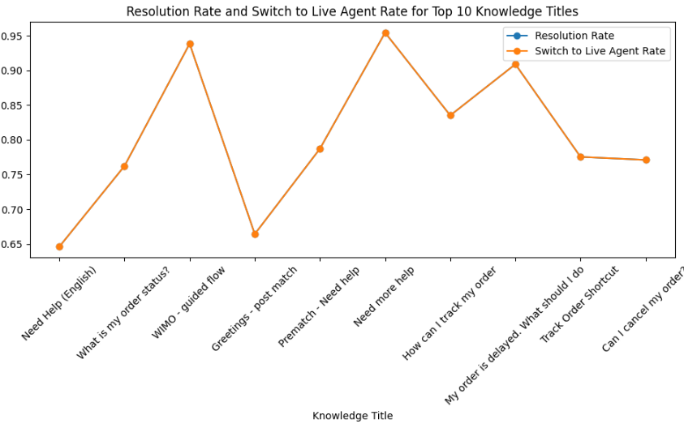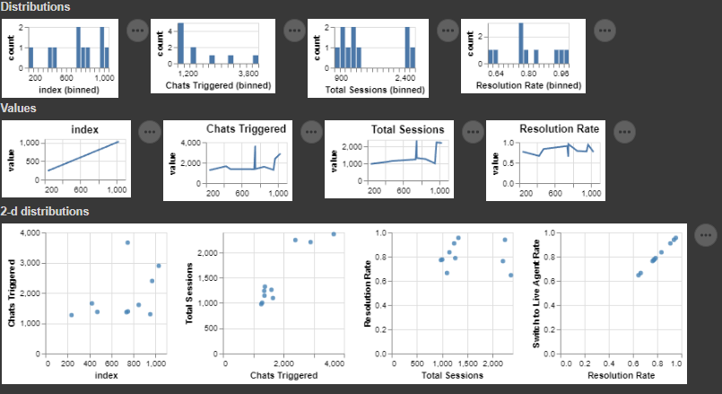

Google Colab Link:

<https://colab.research.google.com/drive/1-x7nSDm9fy18sQuada6hT1Nl_5t_8KYE?usp=sharing>

Case Study

### Question 1.

Table: Comparison Table

| **Feature** | **Negative Response** | **Positive Response** | **Negative Ratio wrt total** | **Positive Ratio wrt total** |
| --- | --- | --- | --- | --- |
| [CHAT]  Is it first chat? | 59070 | 21161 | 73.62% | 26.38% |
| [CHAT]  Is it last chat? | 59066 | 21165 | 73.62% | 26.38% |
| [CHAT]  Is last chat recommendation? | 80231 | NaN | 100.00% | NaN% |
| [CHAT]  Is last chat no answer? | 80231 | NaN | 100.00% | NaN% |
| [SESSION]  Is session unsatisfied? | 74710 | 5521 | 93.12% | 6.88% |
| [SESSION]  Is session last chat no answer? | 80231 | NaN | 100.00% | NaN% |
| [SESSION]  Is session click to agent? | 68625 | 11606 | 85.53% | 14.47% |
| [SESSION]  Is session last chat recommend not clk? | 80231 | NaN | 100.00% | NaN% |
| [SESSION]  Is session intention to agent? | 68265 | 11966 | 85.09% | 14.91% |
| [SESSION]  Is session direct to agent? | 77346 | 2885 | 96.40% | 3.60% |
| **Feature** | **Negative Response** | **Positive Response** | **Negative Ratio wrt total** | **Positive Ratio wrt total** |
| [SESSION]  Is session switch to agent? | 56985 | 23246 | 71.03% | 28.97% |

#### Analysis

**[CHAT] Is it first chat?:**

73.62% of interactions in the sample are not the users' initial chats. This shows that before starting the current session, consumers frequently have previous interactions or history with the chatbot.

**[CHAT] Is it last chat?:**

Similarly, the majority of conversations (73.62%) do not mark the end of the session. This suggests that consumers frequently engage in additional interactions or carry on a conversation with the chatbot after posing their first question.

**[CHAT] Is last chat recommendation?:**

The dataset doesn't offer any statistics on favorable responses for this feature. If any recommendations from the previous chat were made, further investigation is required to ascertain their relevance to the outcomes of the session.

**[CHAT] Is last chat no answer?**:

For this feature, every interaction in the dataset is marked as a negative response. This suggests that there were open questions or unsatisfied users in the previous session.

**[SESSION] Is session unsatisfied?:**

The majority of sessions (93.12%) are classified as unsatisfactory. This could mean that when users interact with the chatbot, their requirements or expectations are not being sufficiently addressed.

**[SESSION] Is session last chat no answer?:**

The last chat's unanswered questions appear to be a role in the session's overall disappointing results.

**[SESSION] Is session click to agent?:**

85.53% of sessions had users click a button to switch to a live agent during the chatbot encounter. This suggests a need for human interaction and that the chatbot could be unable to adequately address some user requests or inquiries.

**[SESSION] Is session last chat recommend not clk?:**

For this feature, there is no information on good responses. To determine whether suggestions made during the previous chat affected consumers' choice to switch to a live agent, more investigation is required.

**[SESSION] Is session intention to agent?**

85.09% of sessions reflect users' intent to interact with a live agent, which is a large percentage.

Users may have specific needs or difficult questions that they feel call for humanitarian aid.

**[SESSION] Is session direct to agent?:**

3.60% of consumers' requests to speak with a live agent directly, rather than interacting with the chatbot, occur within relatively few sessions. This shows a definite preference for human aid from the very beginning of the contact.

**[SESSION] Is session switch to agent?:**

Users frequently switch between a chatbot and a live agent during interactions (71.03% of sessions). This shows that users may need assistance from a human agent if the chatbot's capabilities or performance fall short of their expectations.

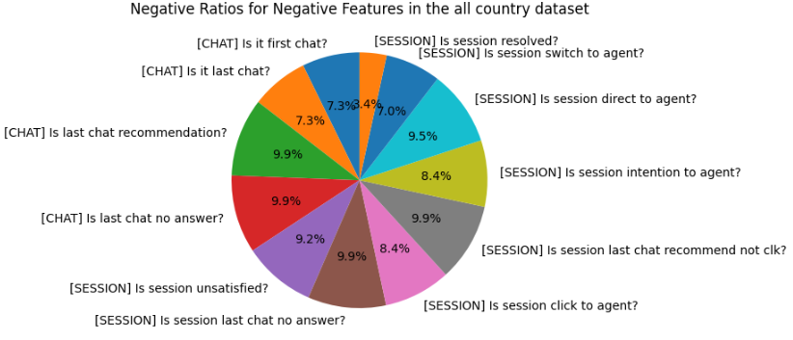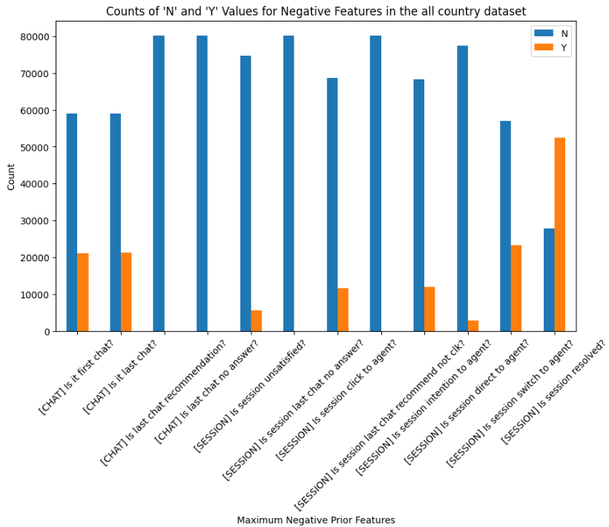

Fig. Comparison Graphs

Improving the chatbot's capacity to respond with appropriate responses, particularly in the most recent session. addressing questions that go unanswered and decreasing user annoyance throughout sessions. Enhancing chatbot functionality to reduce the need for users to move to live agents or request human support. Examining the drivers of consumers' desire to interact with a live agent and devising solutions to handle their unique requirements or challenging inquiries. Investigating the causes of users who approach live agents directly as opposed to using the chatbot. A thorough analysis of each chat conversation, user input, and the environment in which the chatbot is being used should serve as the foundation for the specific enhancements.

**Identify unresolved sessions:** Concentrate on sessions where the [SESSION] Is session resolved based on the data supplied. feature receives an unfavorable reaction. Unresolved is the designation for these sessions.

**Examine the following features:** To learn more about the open sessions, analyze the features mentioned below:

[SESSION] Is session last chat no answer? Check to see if the session's final chat received no responses, which could explain the unresolved state. Check if users commonly click during a session to switch to a live agent in order to determine whether or not human intervention is necessary. [SESSION] Is session click to agent? [SESSION] Is session intention to agent?: Look at whether or not users' intentions to interact with live agents are a cause of unfinished sessions. Look for instances where users directly seek to interact with a live agent, bypassing the chatbot, as this could be a sign of unresolved sessions. [SESSION] Is session straight to agent? Analyze situations where users transfer from the chatbot to a live agent, as this may reveal unresolved session patterns. [SESSION] Is session switch to agent? Is the session not satisfied? Check to see if user annoyance occurs frequently in unresolved sessions.

**Calculate the effect:** For each of the aforementioned elements in the unsolved sessions, determine the frequency and proportion of negative replies. This will make it easier to determine which elements contribute most significantly.

**Root cause analysis:** Determine the primary causes of unsolved sessions in light of the analysis. Look for recurring patterns, typical situations, and connections between the features. For instance, it can be a sign that users are not getting satisfactory responses to their questions if a large number of unresolved sessions have a negative response to the question [SESSION] Is session last chat no answer?

#### Recommendation

Here are some further recommendations to increase the functionality of the chatbot and the client experience as a whole:

1. Enhance the chatbot's natural language understanding (NLU) abilities to better comprehend user queries, even those with complicated or ambiguous terminology. To enhance the chatbot's comprehension of various user intents and linguistic nuances, train it on a larger and more varied dataset.
2. Continually add new, accurate material to the chatbot's knowledge base. Include real-time data sources to make sure the chatbot has access to the most recent data and can respond with responses that are up to current.
3. Make the chatbot more adept at discerning the user's intentions and comprehending the context of the interaction. Use strategies like intent chaining and context retention to keep the conversation flowing naturally and give more precise answers.
4. Employ methods for user profiling to collect and make use of details about specific users, such as their preferences and previous interactions. Utilize this data to tailor the chatbot's suggestions and responses to the individual needs and preferences of the user.
5. Make it possible for the chatbot to proactively offer pertinent suggestions for information or actions based on the user's previous interactions and present context. To improve the general customer experience, anticipate consumer needs, and offer proactive support.
6. By providing pertinent background and transitioning the discussion fluidly, you may streamline the process of switching from a chatbot to a live agent. To enable a seamless handoff and continuation in customer service, put in place methods for real-time communication between the chatbot and live employees.
7. Implement tools to collect user feedback on the chatbot's performance. Analyze the comments to find areas that may be improved, then make the required changes to improve the chatbot's performance over time.
8. Consider adding multilingual support if the chatbot has a broad user base to accommodate users who prefer to communicate in tongues other than the default one.
9. To get information and feedback on the functionality and performance of the chatbot, conduct frequent user testing sessions. Based on user input and observable usage patterns, iterate and improve the chatbot.
10. By delivering concise and educational error messages, the chatbot's error-handling capabilities will be enhanced. Implement escalation processes to address complex or unanswered issues swiftly and effectively, ensuring users get the help they need as soon as possible.

### Question 2.

The performance of a chatbot can be evaluated using a number of metrics in addition to the resolve rate. Here are some extra metrics to take into account:

1. Response Time: Calculate how quickly on average the chatbot responds to user inquiries. A chatbot that responds more quickly is more effective and responsive.
2. First Contact Resolution (FCR): Track the percentage of user inquiries that are answered during the initial conversation with the chatbot, without the need for escalation or additional help. A chatbot that can effectively answer user demands without the need for extra support has a higher FCR.
3. Customer satisfaction (CSAT): Gather user comments on how happy they are with the chatbot's performance. Post-interaction polls or ratings can be used for this. CSAT offers a precise indicator of user happiness and aids in evaluating the overall effectiveness of the chatbot experience.
4. User Engagement: Measure the degree of user interaction with the chatbot, such as the number of interactions per session, the length of each session, or the depth of each conversation. A chatbot experience that is more valuable and interactive will have higher user engagement.
5. Abandonment Rate: Monitor the percentage of users that give up on or leave a chatbot engagement before their questions are answered. A reduced desertion rate suggests more user engagement and retention with the chatbot.
6. Escalation Rate: The percentage of user inquiries that must be escalated from the chatbot to a live agent or higher level of support is known as the "escalation rate." The chatbot may be able to efficiently handle a larger range of user inquiries if the escalation rate is lower.
7. Self-Service Rate: Calculate the proportion of customer inquiries that are completely addressed by the chatbot without the need for additional help from a human. A greater self-service rate suggests that the chatbot can deliver thorough and correct responses.
8. Error Rate: Keep track of how frequently the chatbot produces mistakes or wrong responses. Higher accuracy and dependability of the chatbot's responses are indicated by a reduced mistake rate.
9. Conversation Completion Rate: Calculate the proportion of user interactions that are successfully completed without being terminated too soon or leading to a user drop-off. An improved and more positive chatbot experience is indicated by a greater conversation completion rate.
10. Repeat Usage Rate: Track the percentage of people who use the chatbot repeatedly by looking at the repeat usage rate. Higher user happiness and trust in the chatbot's abilities are shown by a higher rate of recurrent usage.